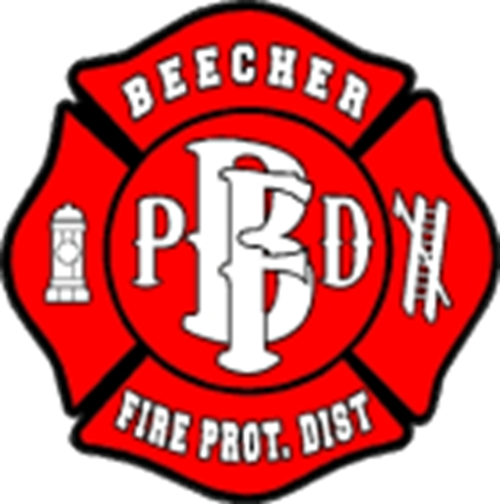
Beecher Fire Protection District
711 Penfield Street
Beecher, IL 60401
(708) 946-6585
Employment Opportunity
The Beecher Fire Protection is accepting applications for part-time Firefighter/Paramedic. These positions require a variety of responsibilities including but not limited to, extinguishing, and preventing fires. Work involves training for and participating in the protection of life and property by firefighting, fire prevention, public education, and rescue activities. Work includes firefighting, rescue, emergency medical care, efficient operation of equipment, and maintenance of facilities and equipment. Although work is performed under general supervision and established regulations, it requires initiative, and an individual understanding of firefighting, fire prevention, rescue methods, and emergency medical techniques.
REQUIREMENTS:
Firefighter/Paramedic: Applicants must have Basic Operations Firefighter certification and Paramedic license at time of application, valid class B Non-CDL driver license and CPR certification. Must be willing to test into Presence St. Mays EMS system.
SHIFTS AND SCHEDULING:
Shifts are 12 hours or 24 hours. Start of shift is 6:00am & 6:00pm. Shifts follow Black, Red, and Gold system.
PAY SCALE:
Starting hourly rate of $17.20/hr, after 1 year, $18.20/hr.
HOW TO APPLY: Qualified individuals interested in applying can pick up an application packet at the fire station during normal business hours (8am- 4pm) or download from www.beecherfire.org.

The Beecher Fire Protection District is an Equal Employment Opportunity Employer.

